**[2CEIT503: COMPUTER NETWORK]**

Practical: 2



**AIM: Implementation of small network using HUB or SWITCH by which more than 2 PC’s can communicate.**

1. Design Peer to peer Network.
2. Design Star Topology.



**Department of Computer Engineering/Information Technology**

**Appliances:**

1. Two laptops

2. 1 LAN cable

# Simplification:

# 8GB RAM

# RYZEN 5 CPU (6 Core, 12 Thread) 3.30GHz

# NVIDIA GTX 4GB GPU

# PC1: Windows 11 and PC2: Windows 10

# 512GB SSD

**Connecting 2 PC’s with LAN Cable:**

* Plug one end of the Ethernet cable in the first system and the remaining end in the second system.

**Step 1):** Here in the below given figure, we have physically connected two PC’s using LAN cable.

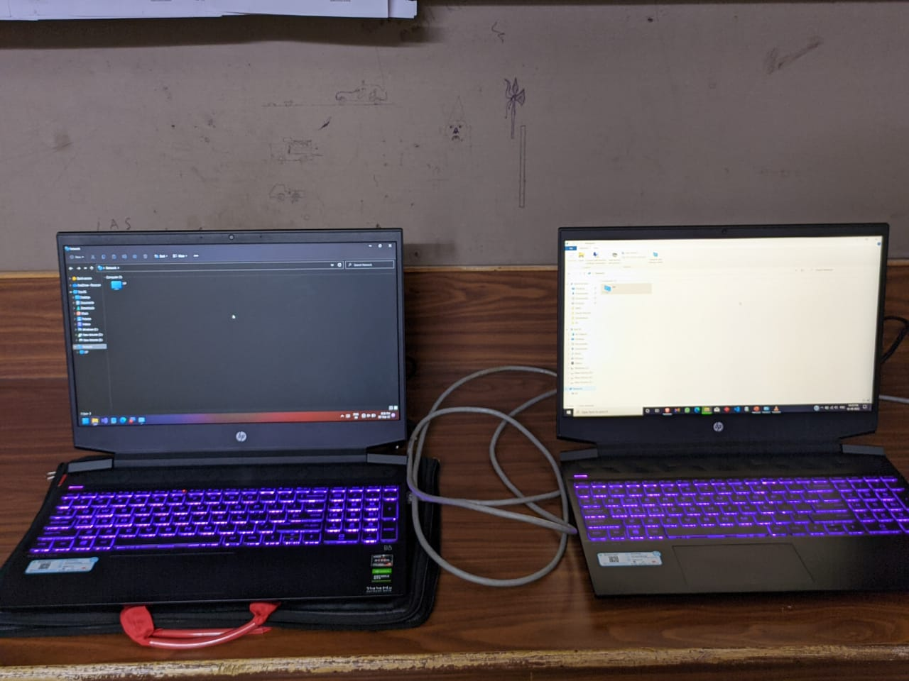

**Step 2):** Once the Ethernet cables are plugged in both the systems, open Control Panel. Press the start button and type control panel or press “WIN **+ R**” and type “control panel” and press enter.

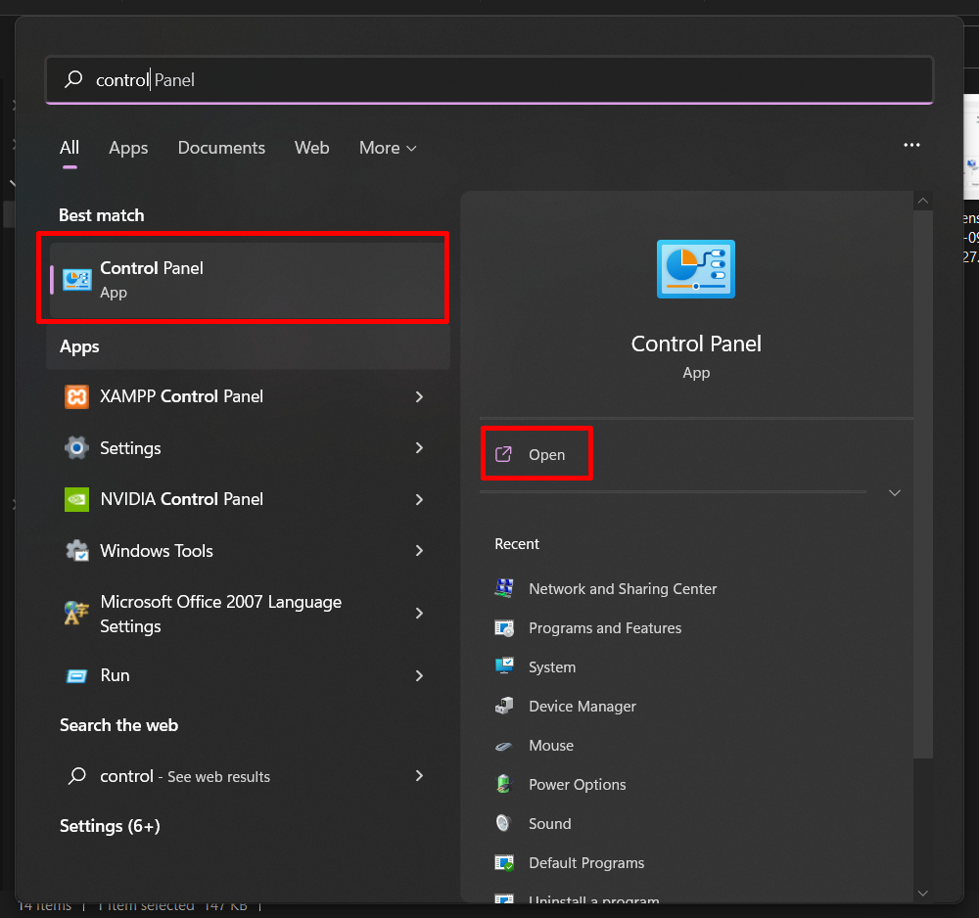

**Step 3):** In the control panel select the “**Network and Internet**” option.

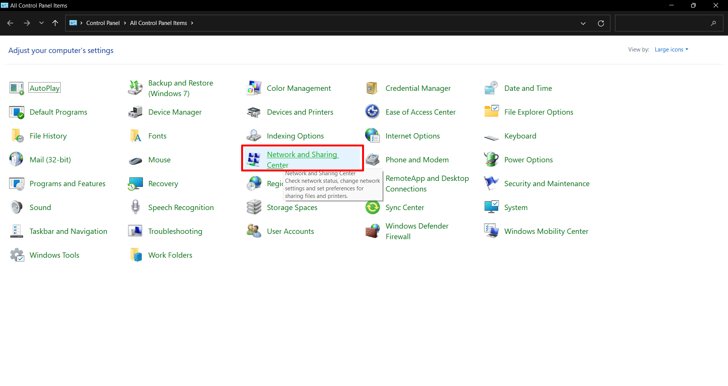

**Step 4):** From upper left portion of screen select “**change advanced sharing settings**“.

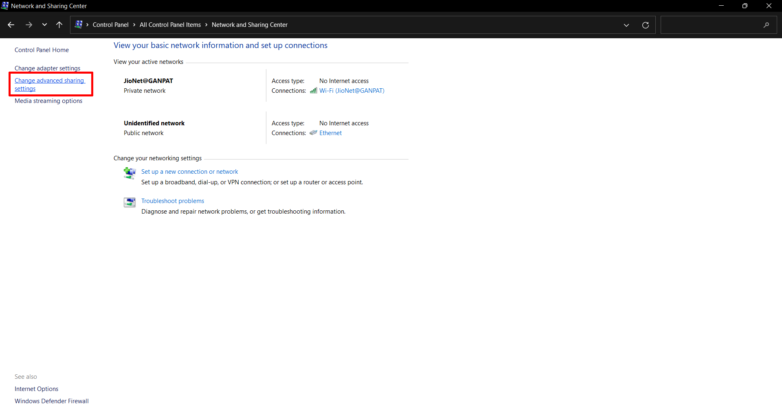

**Step 5):** Under “**Network discovery**” select “**Turn on network discovery”** and Under “**File and printer sharing**” select **“Turn on printer sharing**” option.

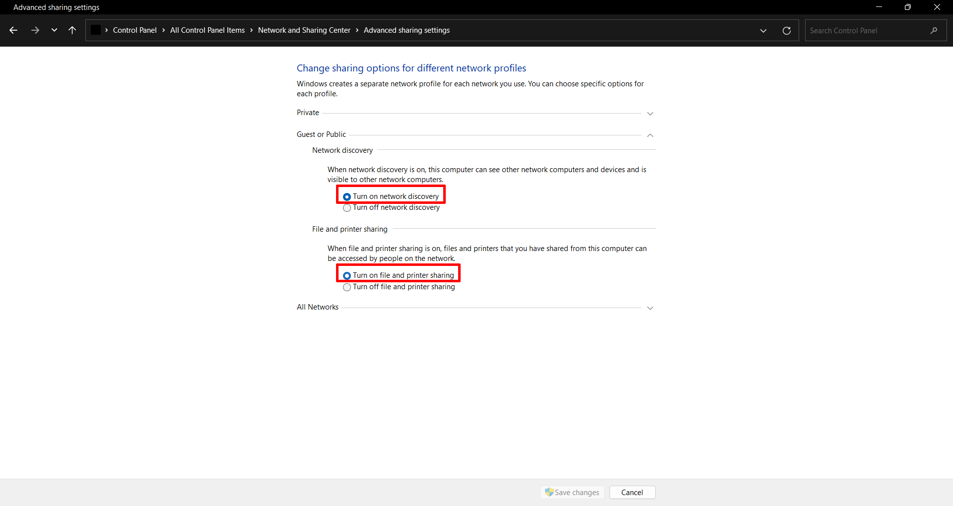

**Step 6):** After that under All Networks select “**Turn on sharing to anyone with network access can read and write files in the public folders**”.

**Step 7):** Under Password protected sharing select “**Turn off password protected sharing”**.

**Step 8):** Then click on “**Save Changes**”.

**Similarly settings apply on PC2.**

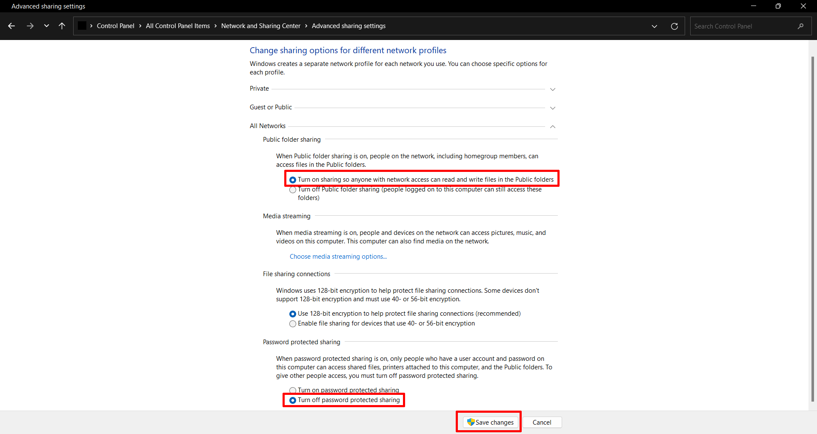

**Step 9): After that, check connections it will show “Ethernet” click on it.**

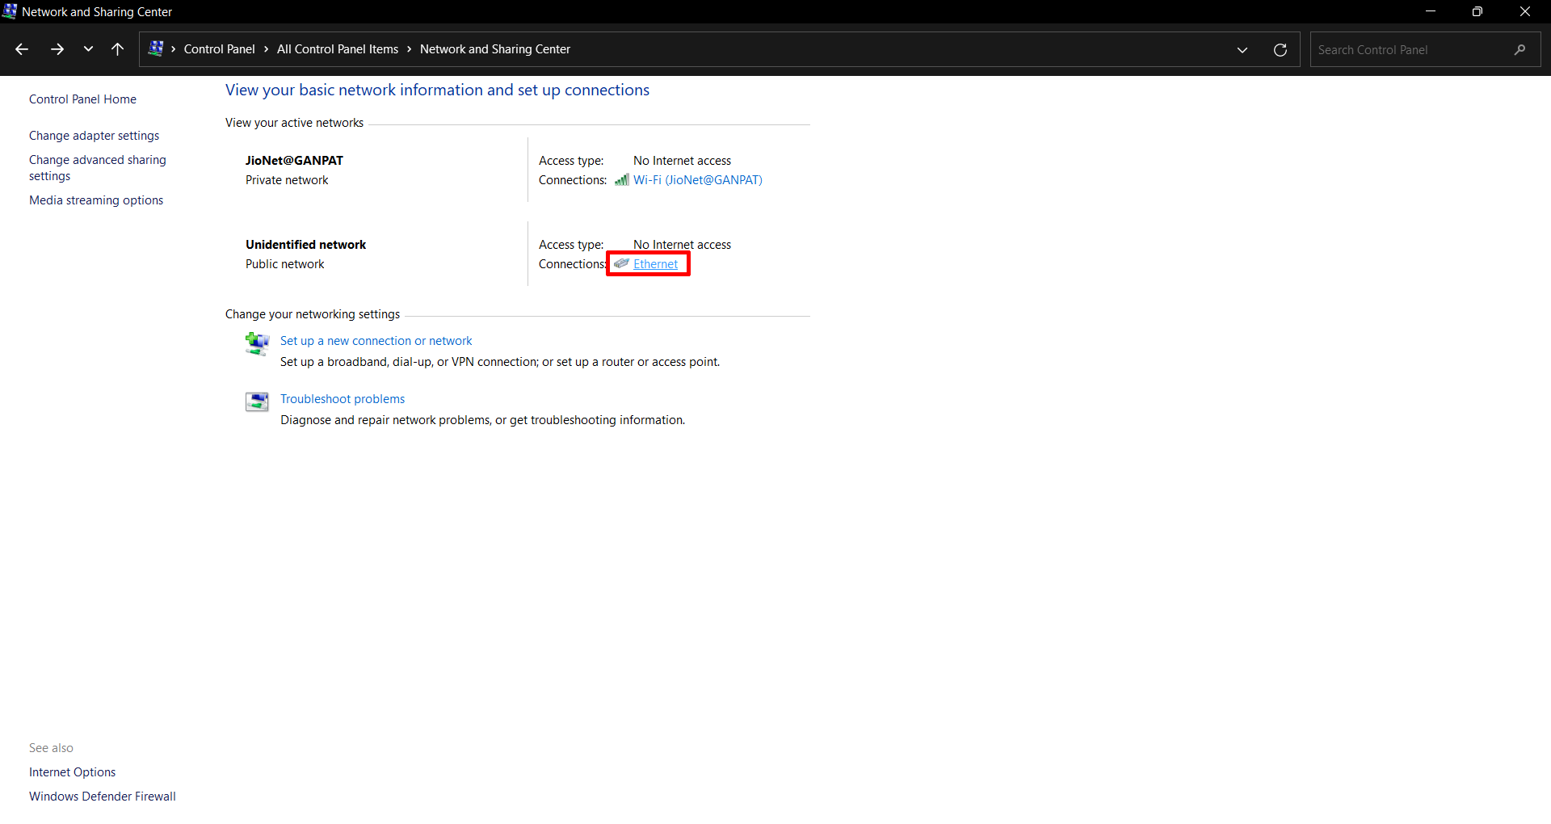

**Step 10): Tap on “Properties” and Double click on “Internet Protocol Version 4 (TCP/iPv4)”**

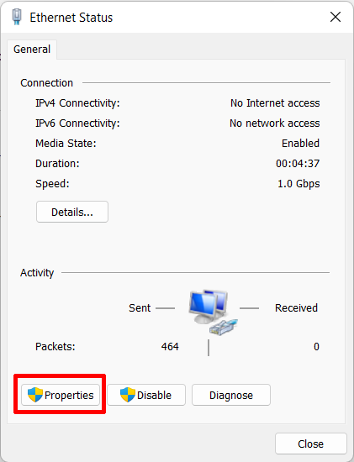 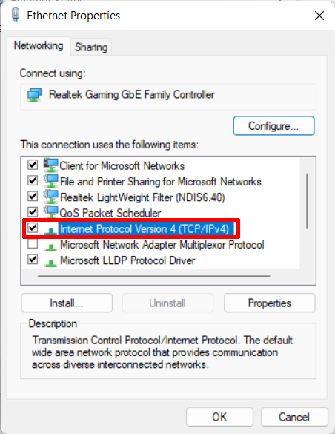

**Step 11):** After double clicking on that select **“Use the following IP address”** and give the value to the IP address, Subnet Mask and Default Gateway of PC1**.**

* Put “**IP Address**” of PC2 in Default gateway of PC1.

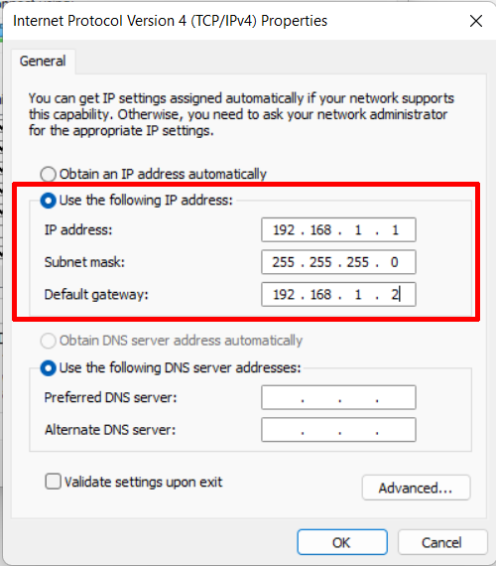

**Step 12): Similarly give the value to the IP address,** Subnet Mask and Default Gateway of PC2.

* Put “**IP Address**” of PC1 in Default gateway of PC2.

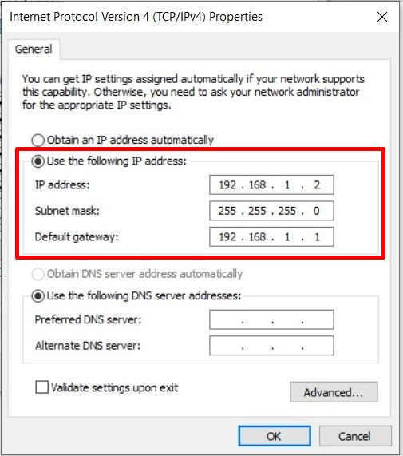

**Step 13): Go to This pc and select the “properties” of “New volume (D)”.**

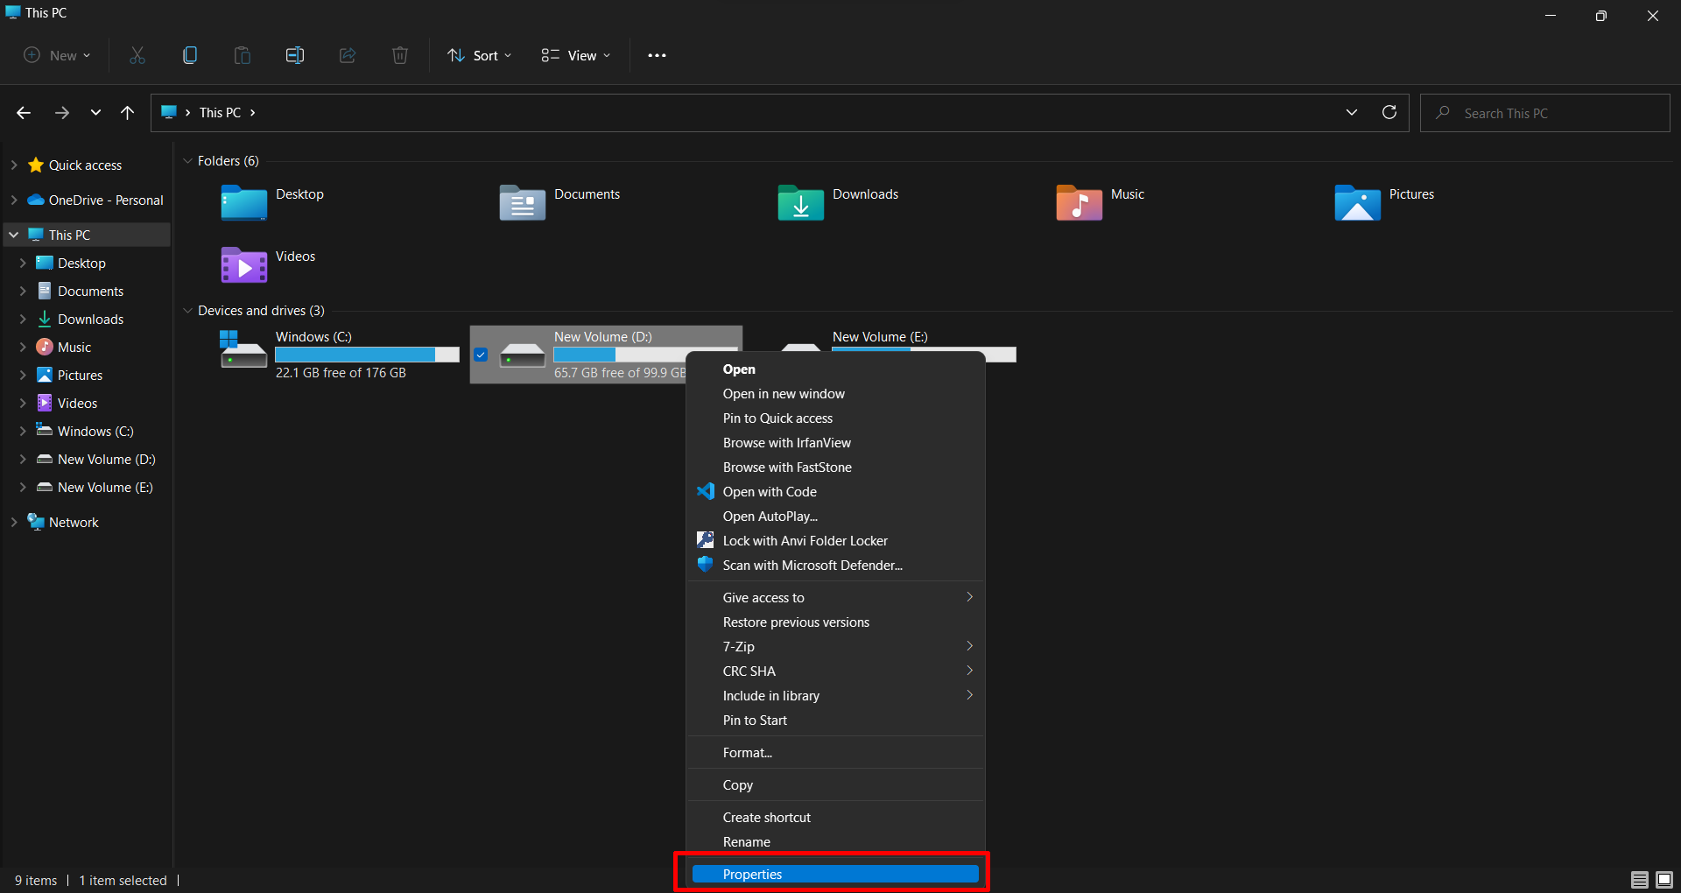

**Step 14): Then after select “Sharing” tab and tap on “Advanced Sharing”.**

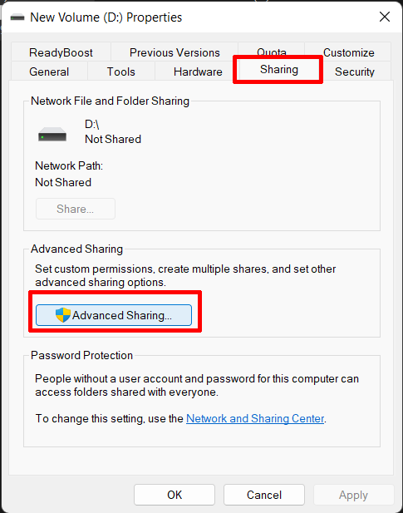

**Step 15): In Advanced Sharing select “Share this folder” and Click on “Permissions”.**

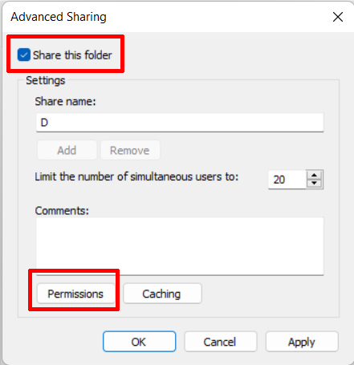

**Step 16): In Share permission “Add” “Everyone” in Group or username. Give permission as you want. I can give “read” permission and click on “Apply” and “OK”.**

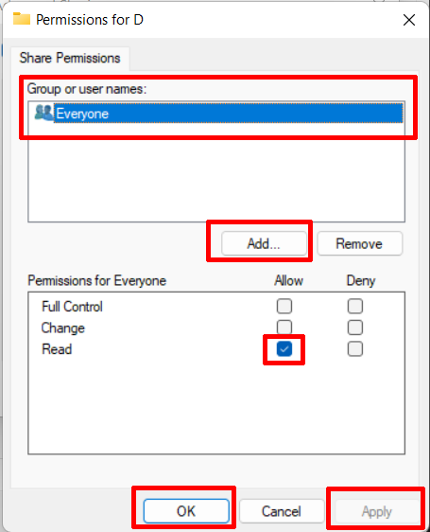

**Step 17): After giving permissions to PC1, the “D drive” will be available in PC2, so we can access data of PC1’s D drive easily in PC2.**

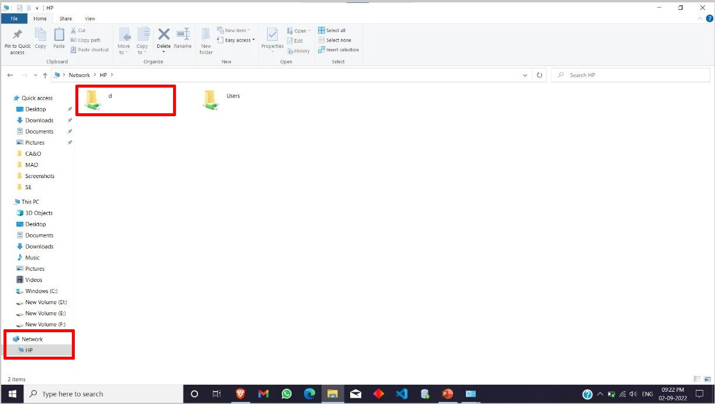

**If you need to share only particular folder follow steps.**

**1).** “**Right Click**” on the Folder you want to share. After that, go to “**Give access to**” and from the two options that appear, go to “**Specific people**”.

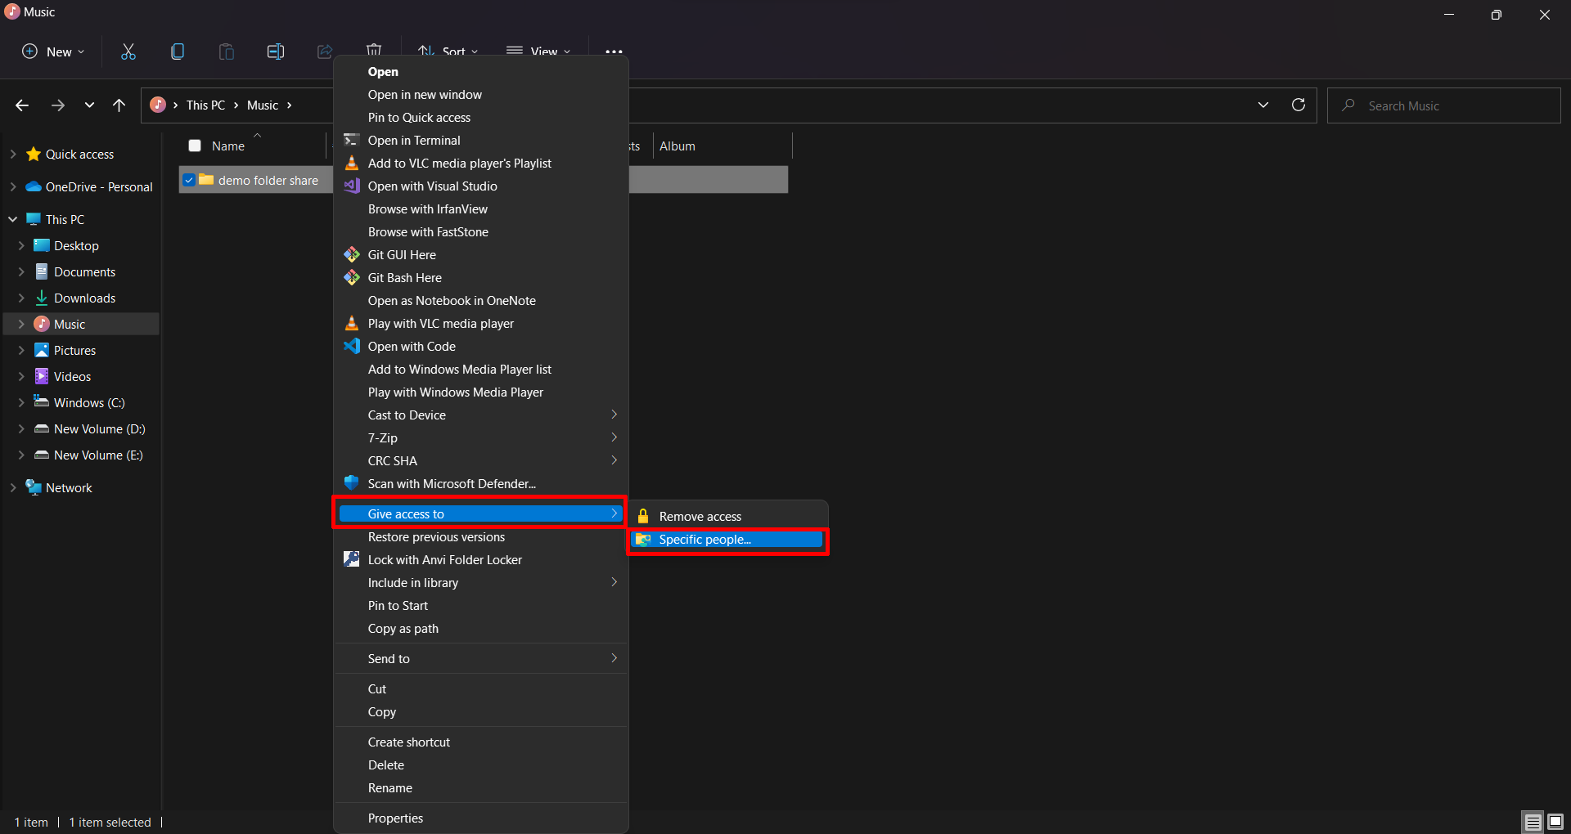

**2).** After that click on the drop down given in it select “**Everyone**” from it.

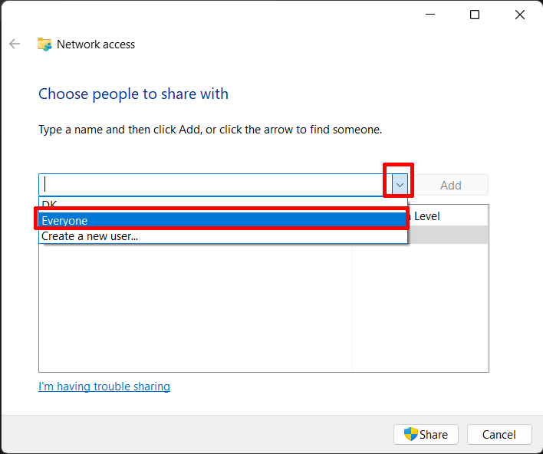

**3).** The click on “**Add**” button. Clicking on “**Add**” “**Everyone**” adds it to the user list.

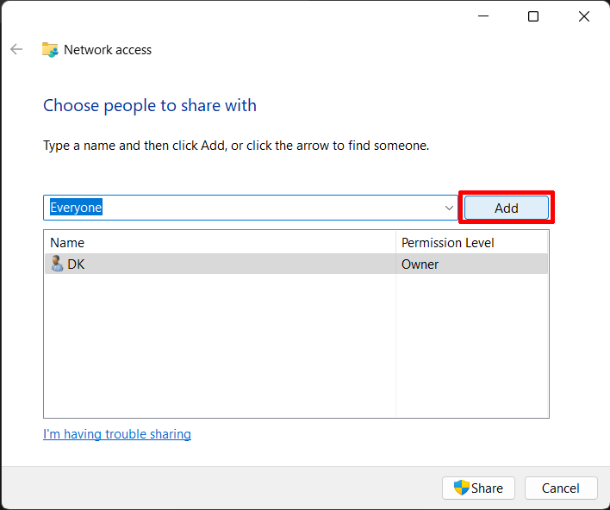

**4).** Give the permission as you want. I can give only “**read**” permission. After that, click on “**Share**”.

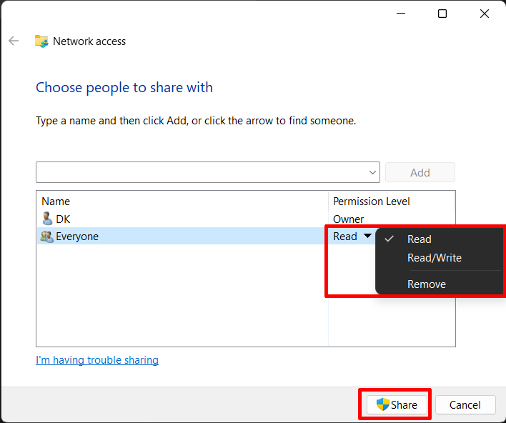

**5).** After that click on “**Share**” we see you folder is shared. After that click “**Done**”.

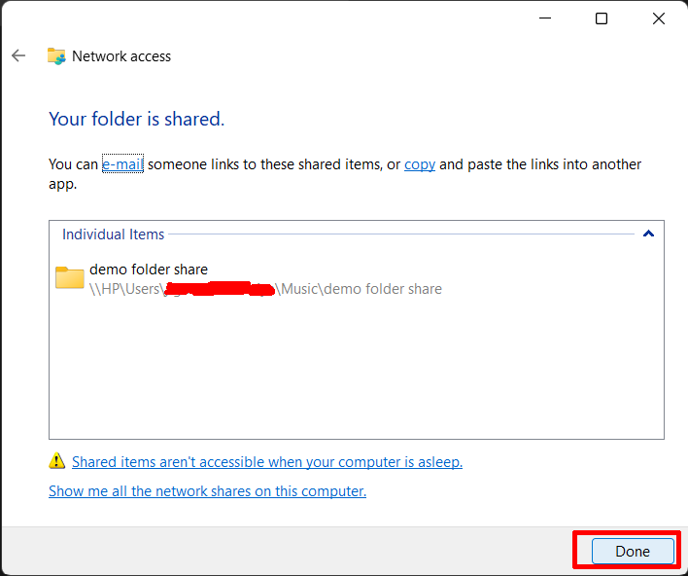

**If you need to stop sharing folder follow steps.**

**1).** “**Right Click**” on the Folder you want to stop sharing. After that, go to “**Give access to**” and from the two options that appear, click on “**Remove access**”.

